I-ROCK Test Data Summary Report

Category: Phyiscal Property Testing

Test Preformed: Density

Test Results: .972 to 1.3 grams/cm³

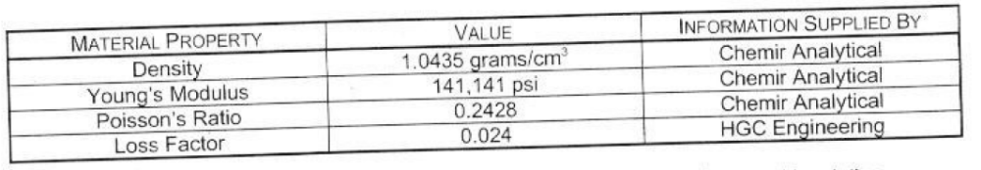

Test Preformed By: Chemir and Sandia

